**Calculating Family Expenses Using Service Now**

Team ID : NM2025TMID17439

Team Leader :

A .Punitha

Team Members:

K. Vijayasree

S. Sasikala

J. Bhavadarani

**Sub Titles**

* Introduction
* Project Objective
* Setting Up Service Now Instance
* Creation of New Update set
* Creation of Table (Family Expenses)
* Creation of Table (Daily Expenses)
* Creation of Relationship
* Configuring Related List on Family Expenses
* Creation of Business Rules
* Configure the Relationship
* Conclusion

**Introduction**

Calculating Family Expenses Using Service Now

A Guided project aimed at creating a structured, scalable, and user-friendly system to track and manage family expenses using the ServiceNow platform

**Project Objective**

The goal of the project is to build a comprehensiveFamily Expenses Calculation System that empowers users to categorize and record expenses set budgets and track them in real time Establish relationships between tables for better data organization .

**Setting Up ServiceNow Instance**

1. Created a personal developer instance(PDI) from Service Now to start Building and testing the application.
2. Open “https:// developer.sevicenow.com”.
3. Personal Developer Instance.
4. Click on Request Instance.
5. Submit the request.
6. Now you will navigate to the servicenow.

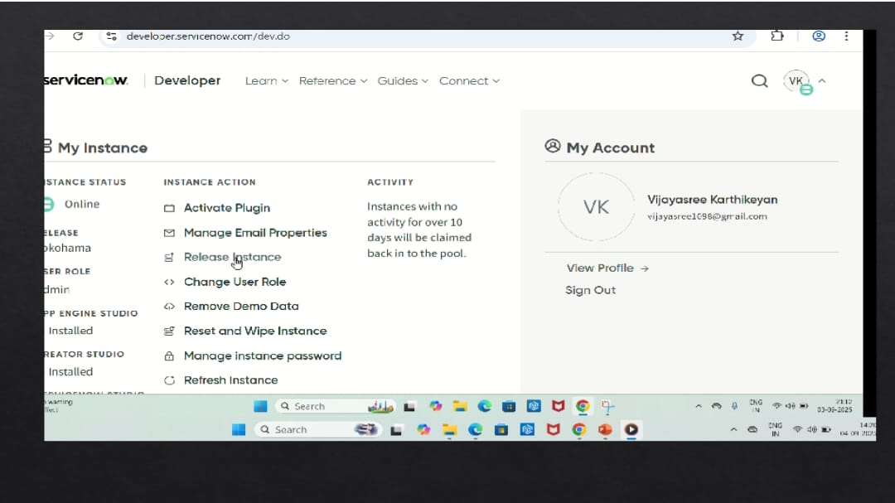

**Creation of New Update Set**

An update set was created to capture customizations and configurations during the project development.

Click Local Update Set

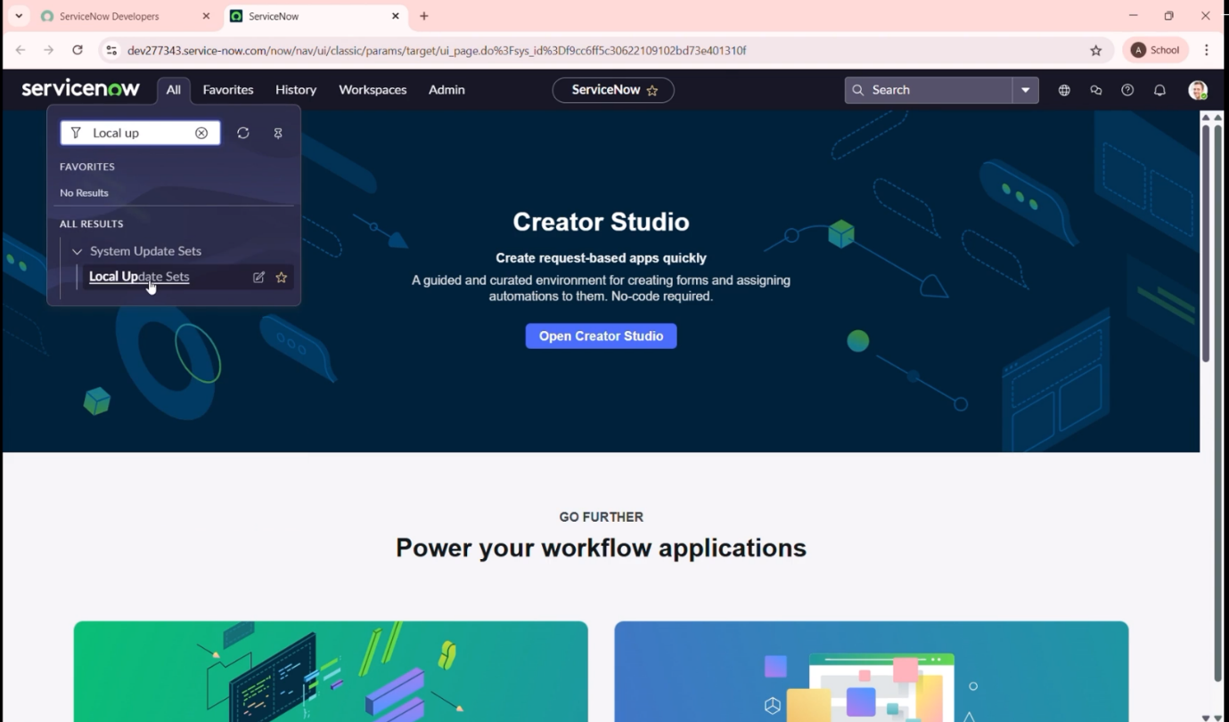

Enter the Details are:

Name : Family Expenses and Click on Submit

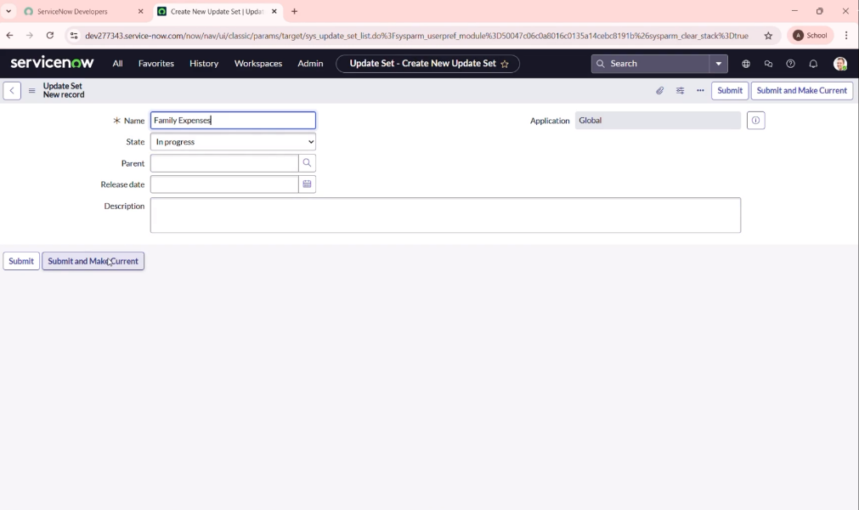

**Creation of Table (Family Expenses)**

A new table was added to store core family expense details like category, amount , and date.

1. Creation of family expenses table

a. Search tables – click on New

b. Label : Family Expenses

Name : Auto – Populated

New menu name : Family Expenditure

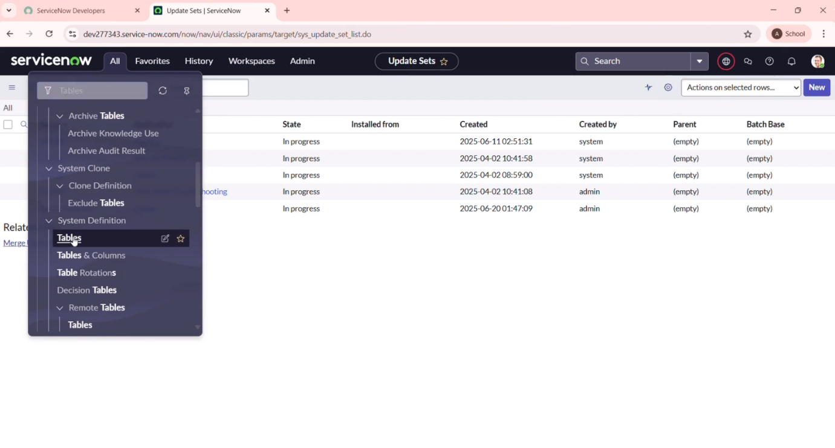

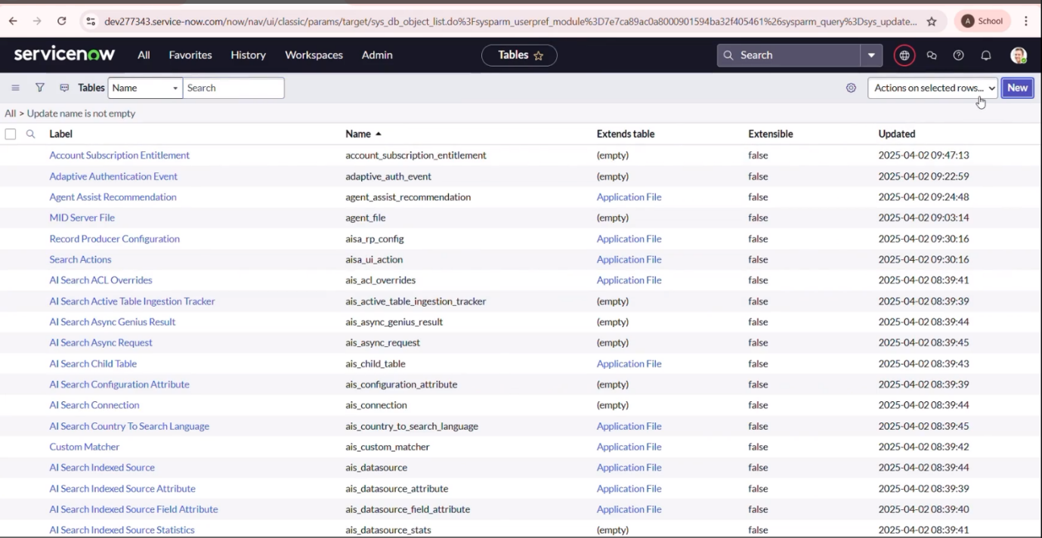

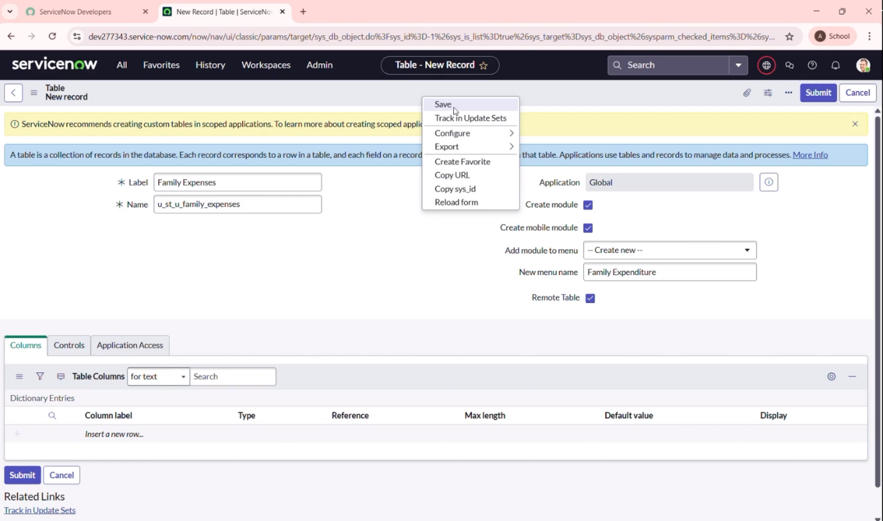

c. Go to the Header and Right click there – click on save

2.Creation of Columns (Fields)

1. Insert a new row
2. Column label : Number

Type : String

1. Column label : Date

Type : Date

1. Column label : Amount

Type : Integer

1. Column label : Expense Details

Type : String

Max length : 800

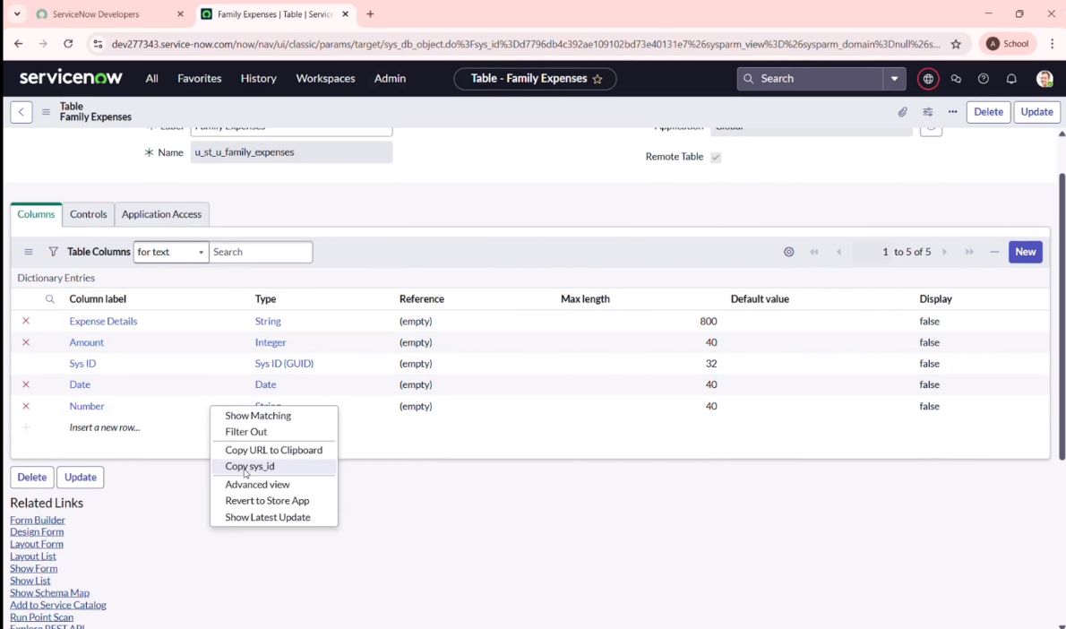

3. Making Number Field An auto – Number

a. Double click on the number field

b. Click on Advanced view

c. Click Default value

Use dynamic default : checks the box

Dynamic default value : Get Next Padded Number

d.Click on update

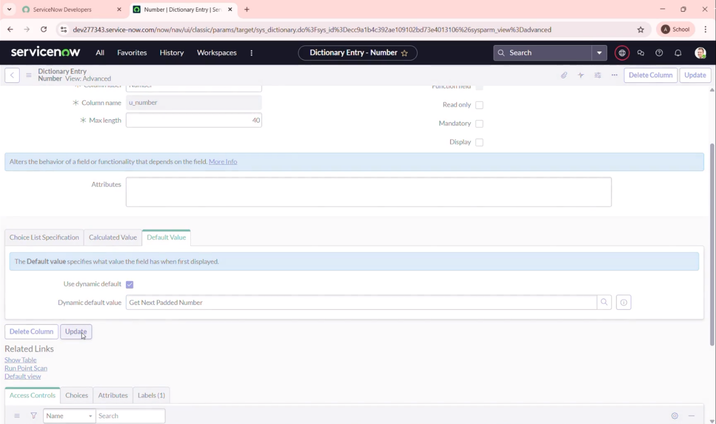

e. Go to all – search for number Maintenance select Number Maintenance

f. Click on new

g. Table : Family Expenses

Prefix : MFE

h. Click on Submit

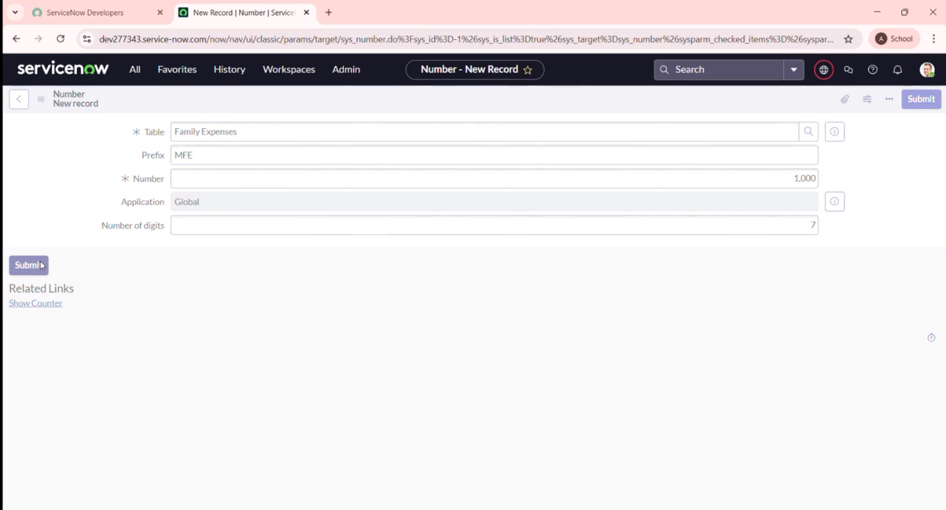

4. Configure The Form

a. Search Family Expenses – Open Family Expenses

b. Click on New

c. Go to the Header and Right click – click on configure select from design

d. Make Number Read – only Field by clicking on the gear icon and checking Read – Only

e. Make Date, Amount Mandatory Field by clicking on the gear icon and checking mandatory

f. Click on save

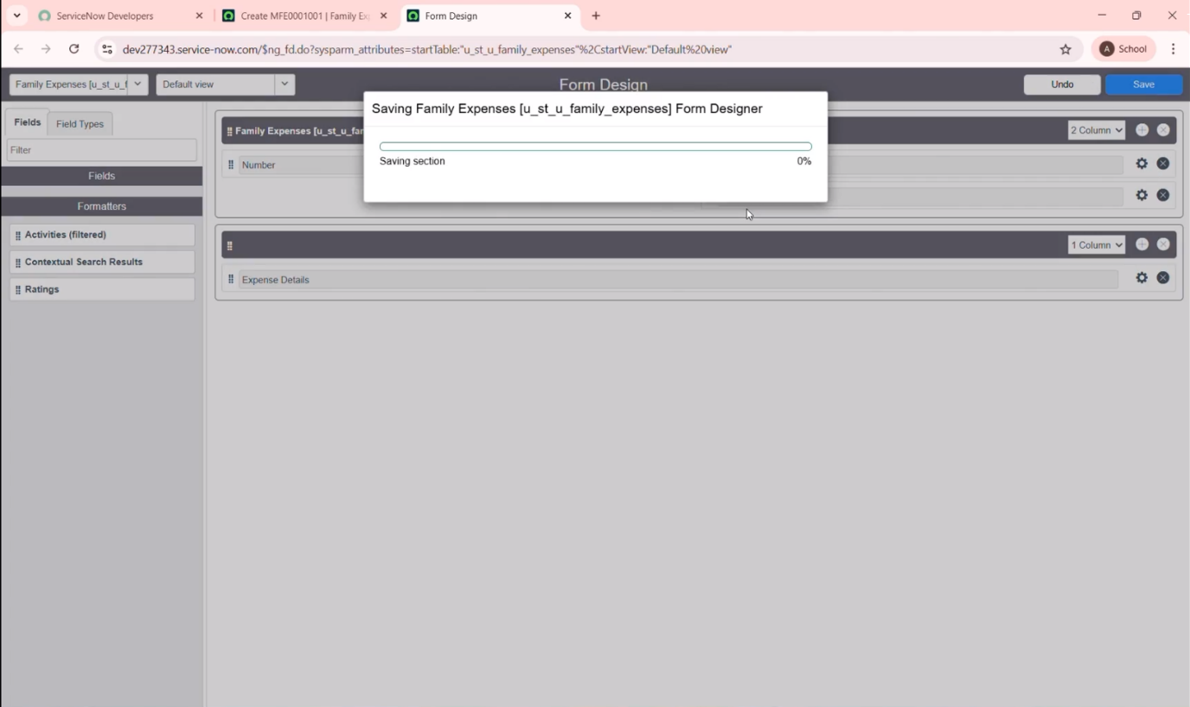

**Creation of Table (Daily Expenses)**

A related table was created to capture individual daily expense entries, linked to the main family record.

1. Creation of daily expenses table

a. Go to All – In the filter search for Tables -click on new

b. Enter the details

Label: Daily Expenses

Name : Auto – Populated

Add Module to menu : Family Expenditure

e. Click on save

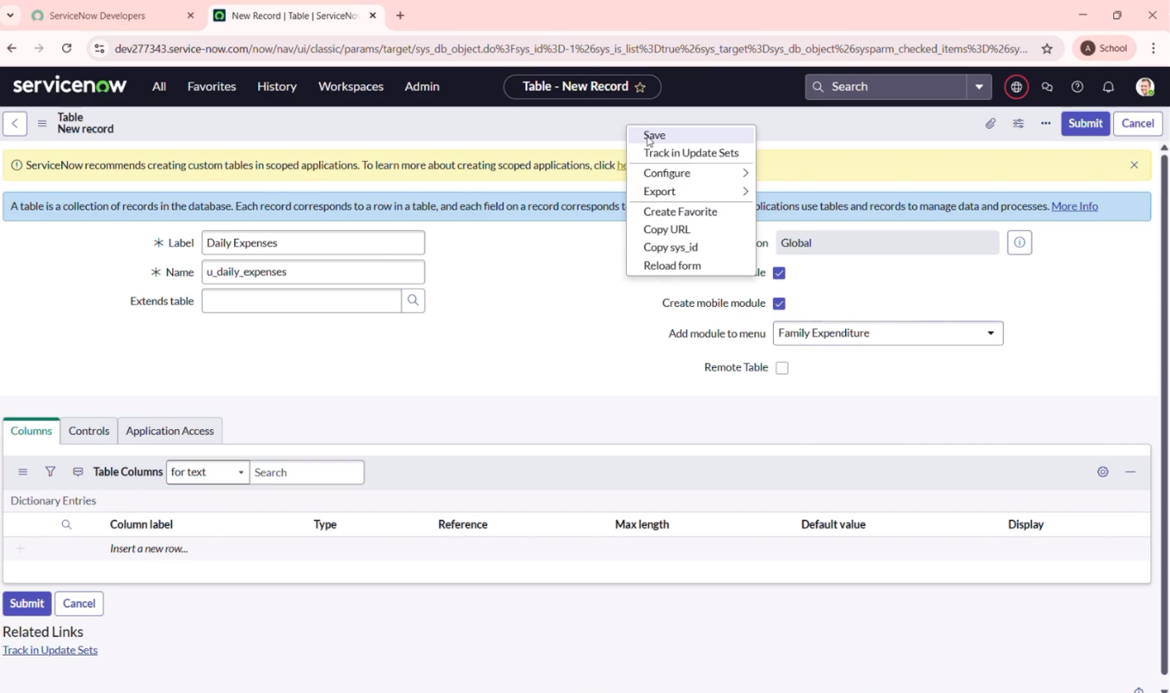

2. Creation of Columns (Fields)

a. Insert a new row

b. Column label : Number

Type : String

c. Column label : Date

Type : Date

d. Column label : Expense

Type : Reference

e. Column label : Family Member Name

Type : Reference Max length: 800

f. Column label : Comments

Type : String Max length: 800

g. Click on Save

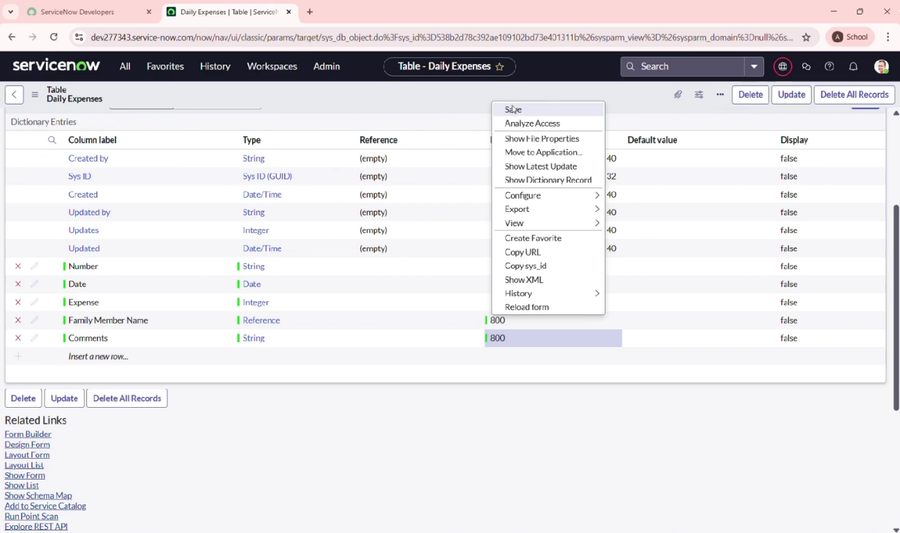

3.Making Number Field An auto – Number

a. Double click on the number Field

b. Click on Advanced view

c. Click Default value

Use dynamic default : checks the box

Dynamic default value : Get Next Padded Number

d. Click on Update

e. Go to all – search for number Maintenance select number Maintenance

f. Click on new

g. Table : Daily Expenses

Perfix : DFE

h. Click on submit

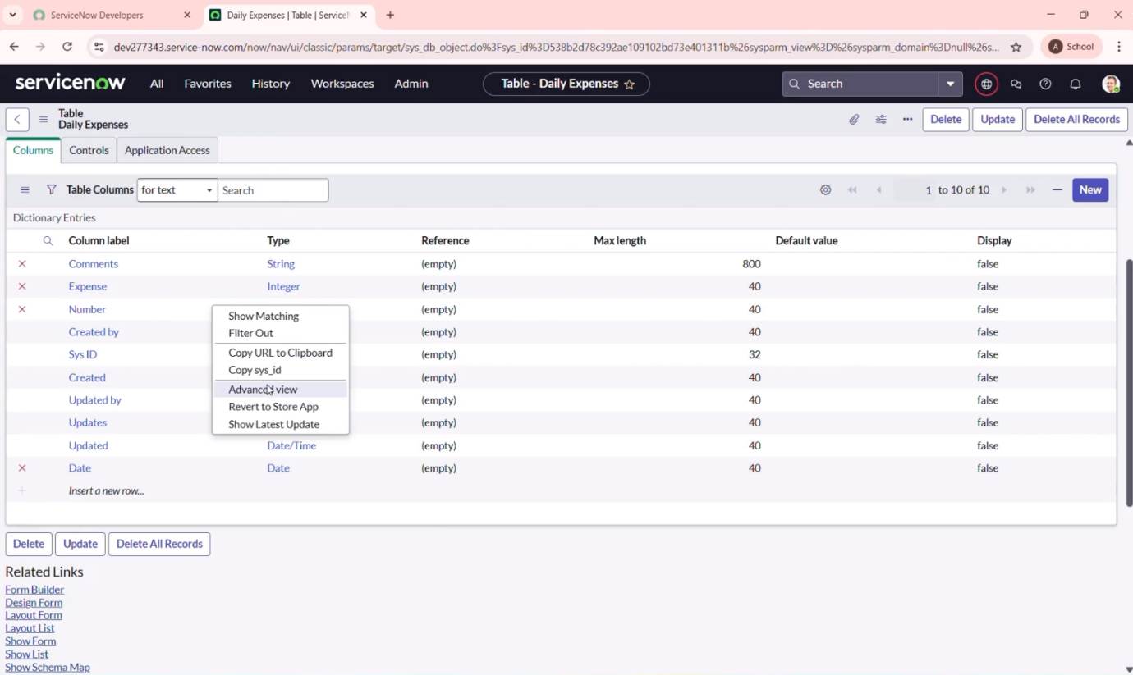

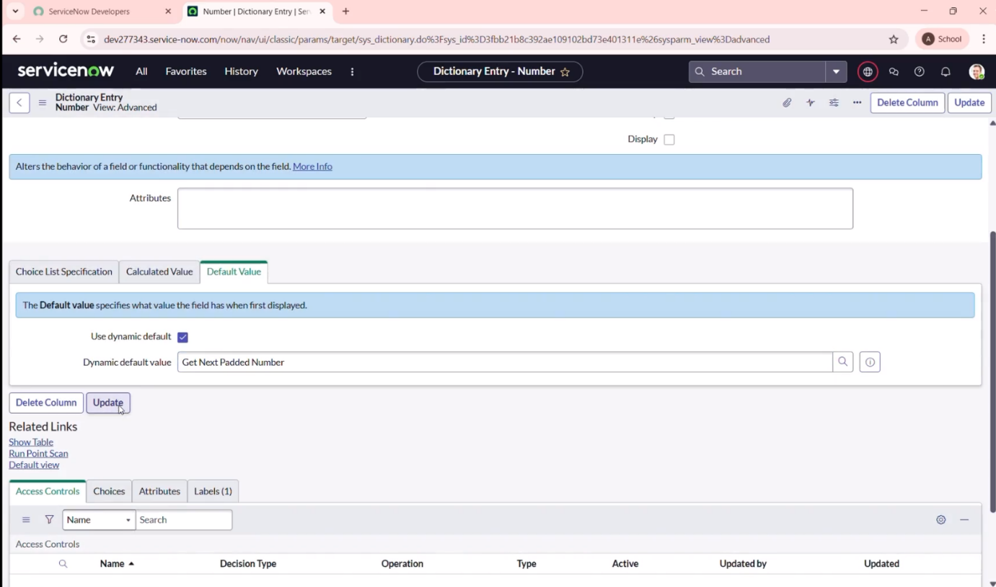

**Creation Of Relationship**

Define the relationship between the family expenses and daily expenses tables to enable hierarchical tracking.

Creation of relationship between family expenses and daily expenses tables

a. Go to all – search Relationships – open relationships

b. Click on New

c. Name : Daily Expenses

Applies to table : Select Family Expenses

Daily Expenses : Select Daily Expenses

d. Click save

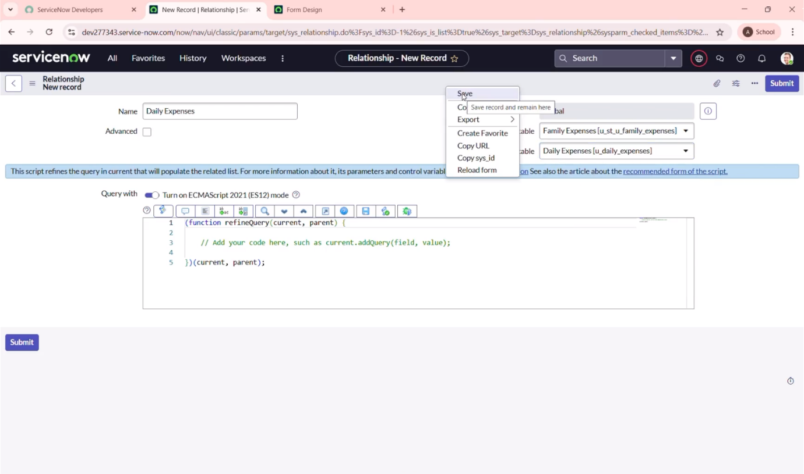

**Configuring Related list on family expenses**

Set up a related list in the family expenses form to view all liked daily expenses for easy reference

a. Go to all – search for Family Expenses – open family Expenses

b. Click on new

c. Click on configure

d. add Daily Expenses to the Selected area

e. Click on save

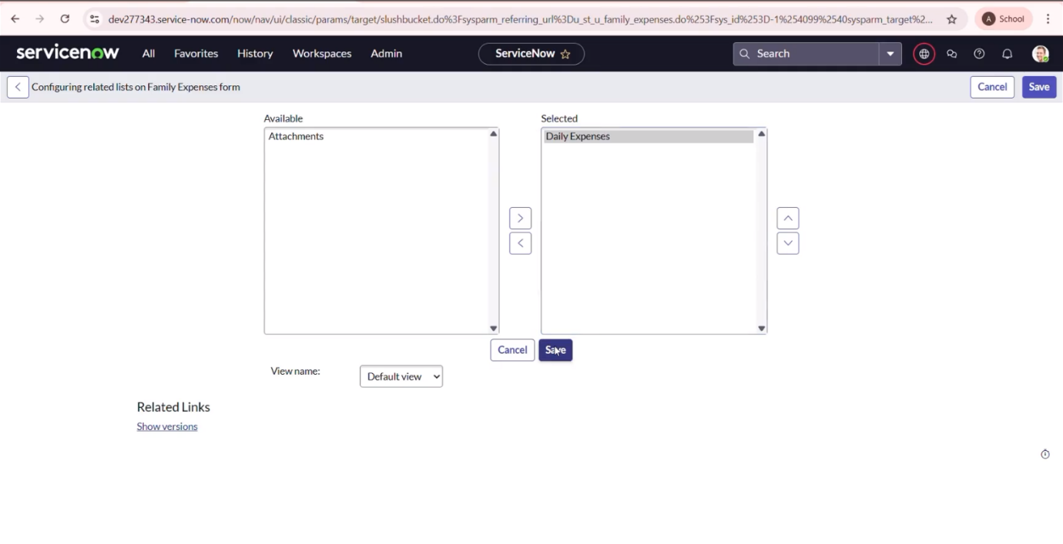

**Creation of Business Rules**

Implemented business logic using Business Rules to automate tasks like field validations, updates, or notifications.

a. Go to all – search – Business Rules

b. Click on new

c. Name : Family Expenses BR

Table : Select Daily Expenses

d. In when to run check insert and update

e. We write the code

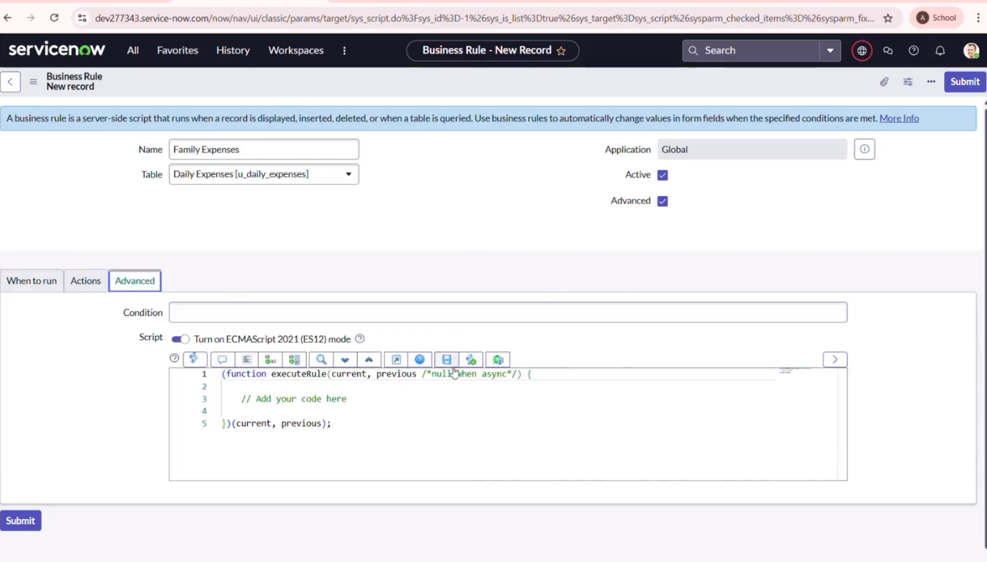

**Configure the Relationship**

Used ServiceNow’s dictionary setting to fine - tune the relationship(one – to – many )Between the tables for accurate data linkage.

a. Go to all – search – open relationship

b. Open Daily Expenses Relationship

c. For applies to table : Select Family Expenses

d. In Query with

e. Click on Update

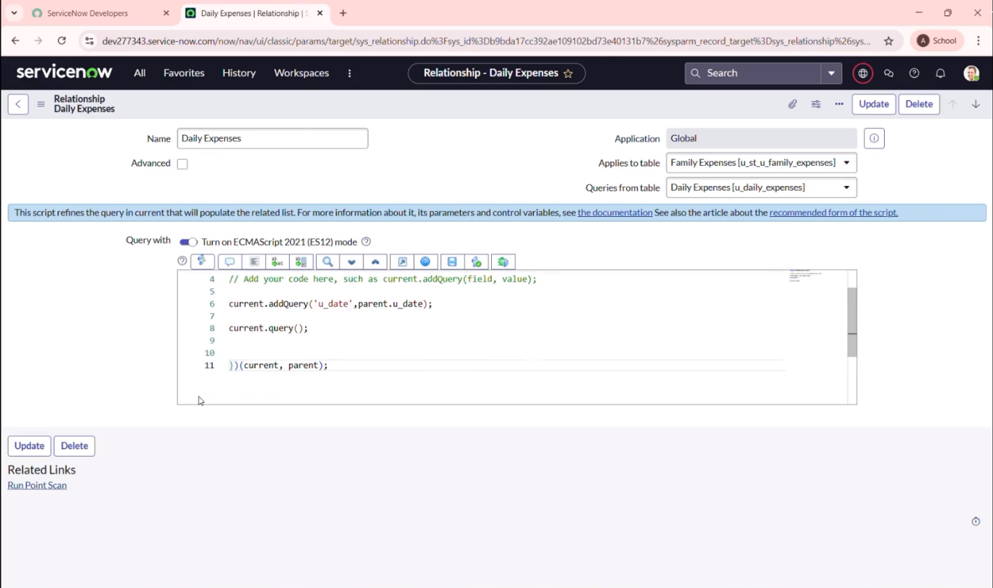

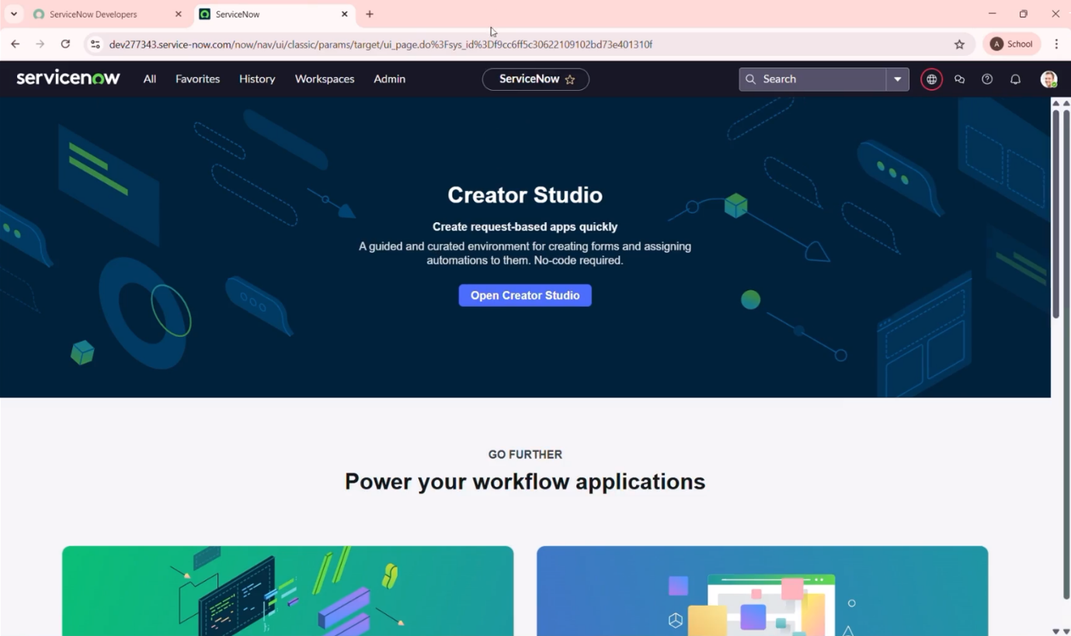

**Conclusion**

Tested the end – to – end application and confirmed that it allows for efficient recording , tracking , and management of family expenses, providing users with a real – time financial overview.